UDC 621.391.3

DETERMINATION OF BLOCK CODES CORRECTING
PROPERTIES LIMITS IN THE SPACE OD SHANNON AXIOMS

Uryvsky L.O., Prokopenko K.A.
Educational and Scientific Institute of Telecommunication Systems,
Igor Sikorsky Kyiv Polytechnic Institute, Ukraine
E-mail: leonid_uic@ukr.net, k.prokopenko@ukr.net

ВИЗНАЧЕННЯ ГРАНИЦЬ КОРИГУЮЧИХ ВЛАСТИВОСТЕЙ
БЛОКОВИХ КОДІВ У ПРОСТОРІ АКСІОМАТИКИ ШЕННОНА

У статті наводиться опис методики побудови меж коригувальних властивостей блокових кодів в просторі аксіоматики Шеннона. Встановлено межі коригувальних властивостей завадостійких кодів на підставі їх граничних можливостей, обумовлених кордоном Плоткина.

This article describes techniques for determination of block codes correcting properties limits in space of Shannon axioms. The block codes correcting properties limits are determined on the basis of their limiting capabilities which are defined by Plotkin bound.
It has been 60 years since the publication of information theory that was formulated by Claude Shannon with postulates and fundamental theorems. It opened the era of bright achievements in area of increasing communication reliability on the basis of channel coding.
According to Shannon theorem, if the source rate does not exceed a value called channel capacity, it is possible to transfer those messages nearly error-free in the noisy channel by selecting method of encoding and decoding [1]. Thus, for the first time it was determined that small error rate can be achieved at the receiving end of noisy channel, if the source rate is limited.
The constructive result of Shannon's theory is Shannon’s theoretical limit – curve that describes maximum informational transfer rate at which it is possible to correct errors in a channel with set signal/noise ratio by error-correcting coding.
For a discrete noisy channel in the case of binary digits transfer the value of channel capacity C is determined by following formula:

$$C=V⋅\left\{1+P_{\text{er}}⋅\text{log}P_{\text{er}}+(1−P_{\text{er}})⋅\text{log}(1−P_{er})\right\},$$ | (1)

where V, bit/s – channel rate;
Рer – error rate for a single character in the channel.
Numerically the multiplier in the brace of formula (1) is the same as the index of relative entropy E1 of the single passed character from the source; it means information content E1 ≤ 1 bit that was saved after the transmission of 1 bit from the binary source via channel as a result of hindrances action.
Thus, the source rate v, bits/s can not exceed the value of channel capacity:
v≤C≤V. Redundancy channel coding is designed to ensure the reliability of receiving source symbols with probability Pb<<Per.
Within Shannon theorem the enormous amount of various codes that can correct a generous amount of errors in channels of different quality has been synthesized.
However, code’s parameters that help to get such results are not indicated. Thus, there is general opinion about non-constructivity of Shannon's theorem for error-correcting codes synthesis.
The purpose of this article is to define the correcting properties limits for channel codes with a given block length using their limiting capabilities by Plotkin bound, and to make the decision about their measure of approaching Shannon’s limit.
Purpose realization should give Shannon's axioms constructive start.

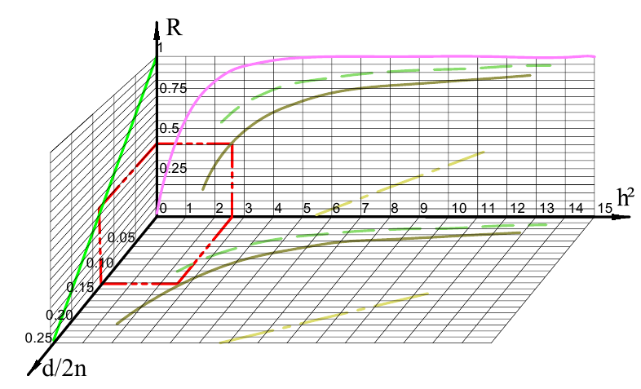
Fig. 1. Findings of correcting properties limits for channel codes

We propose the following sequence of actions in three dimensions to form the correcting properties limits for channel codes:
1. For code with the chosen value of length n and required symbols reliability Pb, based on the method of forming and processing of symbols in a channel with given energy parameter h2, value is determined by the probability Pn (t, h2) = Pb from (4) and (5). Further, the parameter t is converted into parameter d/2n.
For any given values of h2 and fixed value n the curves d/2n {h2; n} are represented on the horizontal plane of Fig 1. Dot-dash line corresponds to n = 10, a solid - n = 50, dashed to n = 100.
2. Using the projection of values d/2n on the Plotkin bound line (left vertical plane in Figure 7) the maximum value R – code rate is defined.
3. At the cross of R and h2 axes projections on the frontal plane in Figure 1 the value of entropy E1 {h2; n} = R is determined, which corresponds to maximum possible ratio between channel capacity C (pink solid line) and transmission source rate v.
For variable h2 values and fixed n (10, 50 and 100) curves E1 {h2; n} = R are shown in the frontal plane of Figure 1.
Trajectory for getting single point of required dependence is shown in red.
From these relationships the main conclusion is that the real codes with length n <∞ does not allow reaching the Shannon limit. At the same time, for block codes with length n, related to the Plotkin bound, it is always possible to determine h2 value in a specified channel, where they provide the specified accuracy over the value of Pb. Larger n causes smaller h2 for fixed Pb.
However, these results demonstrate that increasing code length n makes closer correcting properties limit for block codes to Shannon limit.
Conclusion. The corrective properties limits for error-correcting codes are based on their limiting capabilities defined by Plotkin boundary. Obtained limits make Shannon theorem, where the existence of code, that can be used to transmit information nearly error-free over a noisy channel, is asserted, constructive. However, the real codes with length n <∞ does not allow reaching Shannon limit.
Proposed method involves indication of the new border in relations between the source rate and channel capacity for given channel parameters and known block code length.

References

1. W.E. Ryan and Shu Lin, Channel Codes Classical and Modern. New York, NY: Cambridge University Press, 2009.
2. G. E. Andrews, R. Askey, R. Roy, Special Functions. Cambridge University Press, 2001.
3. J. G. Proakis, Digital Communication, 4th ed. Boston, MA: McGraw-Hill, 2000.

НЕ ВИКОРИСТОВУЙТЕ автоматичного форматування тексту та списків!

